= We don’t want to use HQL,SQL,Native SQL in preparing the persistence logic. We want to create persistence logic completely in the form of “Java code”.Then we should use “Criterion API” or Criterial Query language. To get the data available in RDBMS tables, Hibernate follows one method via Criteria API. **The logical operation, pagination concepts ,sorting concepts, aggregation concepts too supported with criterial query**.

Hibernate provides complete criterion api in two packages.

1. Org.hibernate
2. Org.hibernate.criterion
3. **Criteria:-** The hibernate Session interface provides createCriteria() method,which can be used to create a Criteria object that returns instances of persistence object’s class when your application executes a criteria query.



1. **Criterion:-** The criterion object represents the single expression. The following static methods of “Restrictions” returns criterion object.

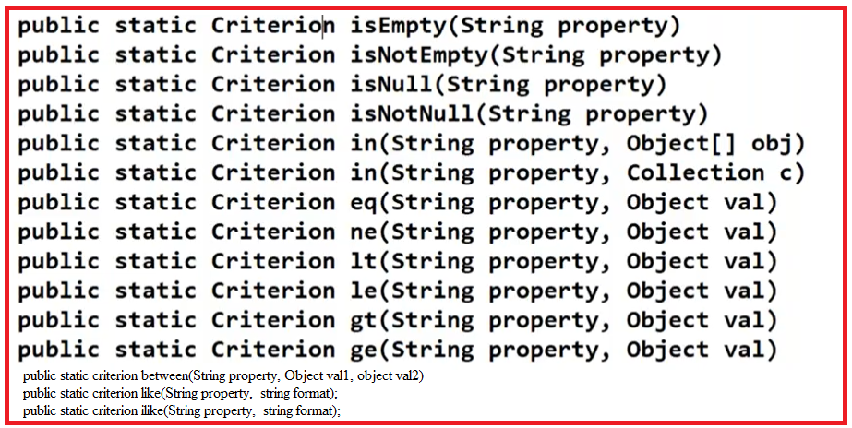

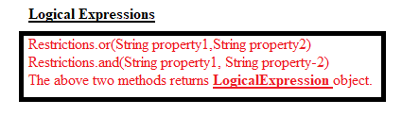

The criterion and Logical Expression objects are to be added to “criteria” object using add(-) method. This method presents in “Criteria” class.



1. **Projections:-** It is in org.hibernate.Criteria package. It have several static methods to get the average, maximum, minimum, sum ..etc of property values and factory methods for obtaining the “Projection” object.

The projection object represents the column name of table or property name of pojo class in persistence logic.

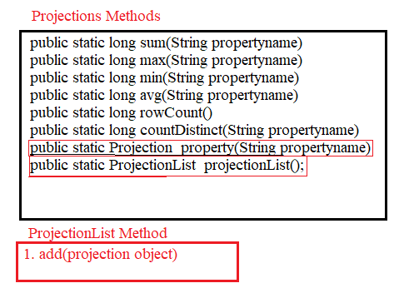

We can add projection List object to Criteria object using following method:

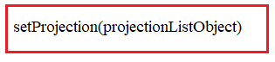

This method presents in Criteria class.

**D.Order:-**

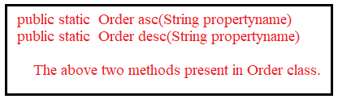

**We should add Order object to Criteria object using following method:**



The method present in Criteria class.